# WEEK 1

8/23/22

* *Find best optical illusions for HW assignment*
* Start preparing for recognizing Poison Ivy.
* Prof Kinsman will stick to 431 and Prof Niu will stick to the grad version
* Book is a reference to everything, use it

Chapter 2 notes:

* Any image can be represented as a 2D function, f(x, y), where f is the intensity of the image at that point.
* Gray level is referred to by the intensity of the gray-scale images.
* All color images are created by combining separate red, green, and blue monochrome images into one.
* 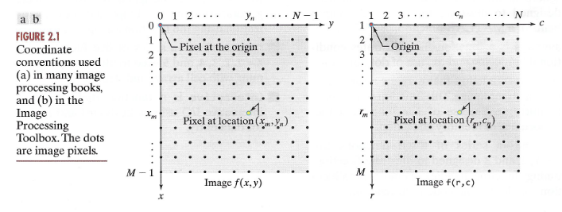
* Use f(r, c) instead of f(x, y) to represent rows and columns.
* We can also use matrices to represent images.
* In Matlab, arrays start at 1, very wrong
* Use *f = imread(‘filename’)* to read a file, then *imshow(f)* to show the image again
* 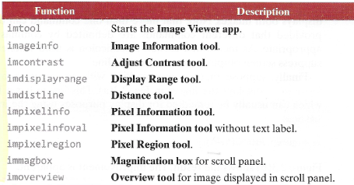

8/25/22

* How do you import headers? you dont
* Matlab is an interpreted language
* You can stop a matlab program by returning or exit()
* Matlab cell mode is made by using %%
* 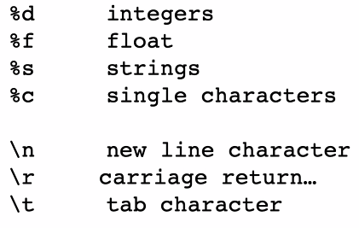
* matlab uses … to continue a line
* Single letter variables were started in Fortran
* ginput is used to get the user’s input

# WEEK 2

8/30/22

* Uint8 is always in the range [0, 255]
* Double images are faster, since there is no clipping
* Metadata- data about the data

9/1/22

* is every variable a matrix, no
* RBG images -> full-color images
* use every unfair advantage you have when taking pictures
* for computing whiteness in an image, logical OR or AND can be used
* we should use color maps for
* 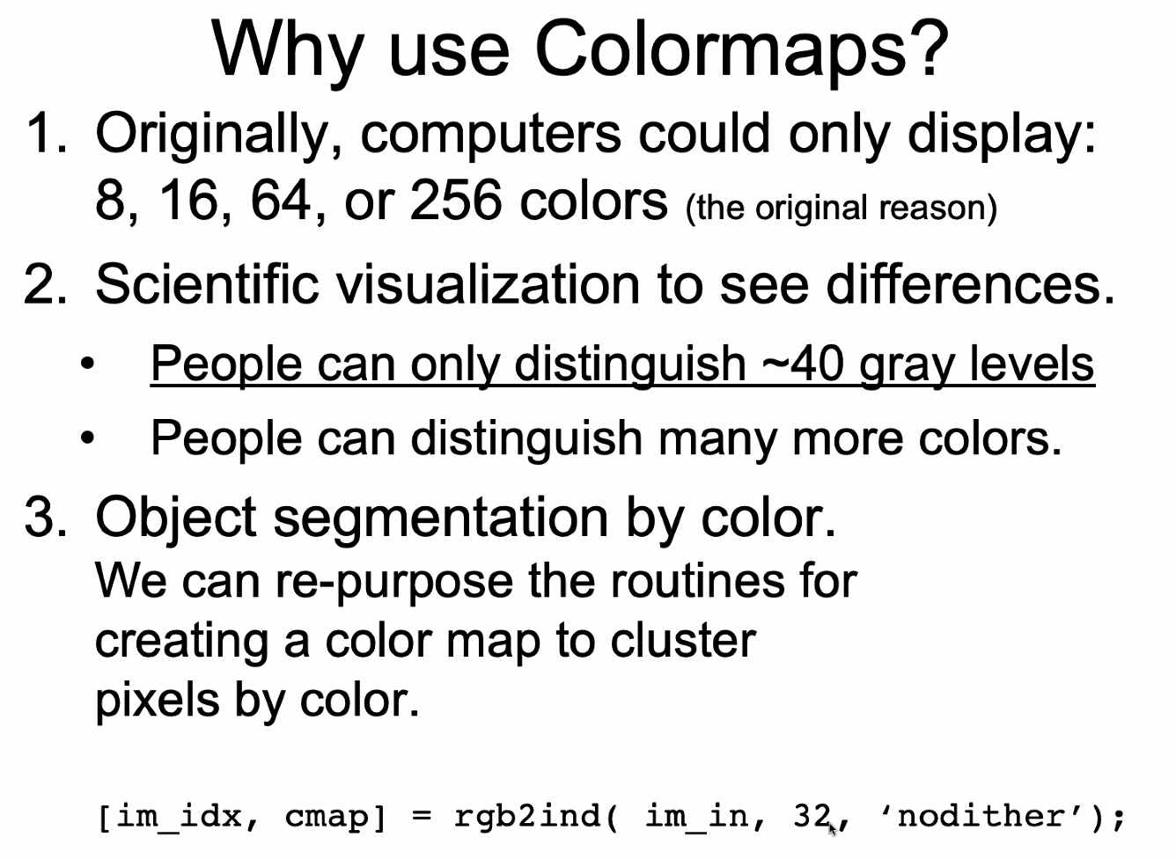

# WEEK 3

9/6/22

* there are four auto algorithms
  + Auto focus
    - moves lens to focus
    - makes the scene look sharp
    - happens before AAA algorithm
    - uses Fourier analysis to maximize the strength of the highest frequencies
  + AAA algorithm
    - Auto exposure
    - Auto contrast
    - Auto white point (for color correction)
    - The world is about 18% gray innately
* False contouring
* Aperture controls the amount of light that a camera gets and how much of the world is in focus. (similar to how our pupils work)

9/8/22

* If the autofocus fails, the image will be too blurry
* If the auto exposure fails, the image overall will be too dark or too bright
* If the auto contrast fails, some parts of the image will be too dark or too bright
* If the auto white fails, the colors will look “wrong”
* Issues with the HVS
  + people can discern 40- 60 different levels of gray
  + dividing the brightness into uniform gray levels, then they will not look like uniform changes
* Contrast enhancements, spacing out the dark colors while compressing the light colors because we can more easily discern light differences than dark differences
* PDS microdensitometer
* False contouring can happen if we have too much compression, too much info is lost
* 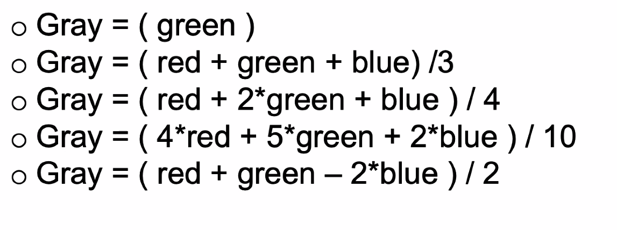
* 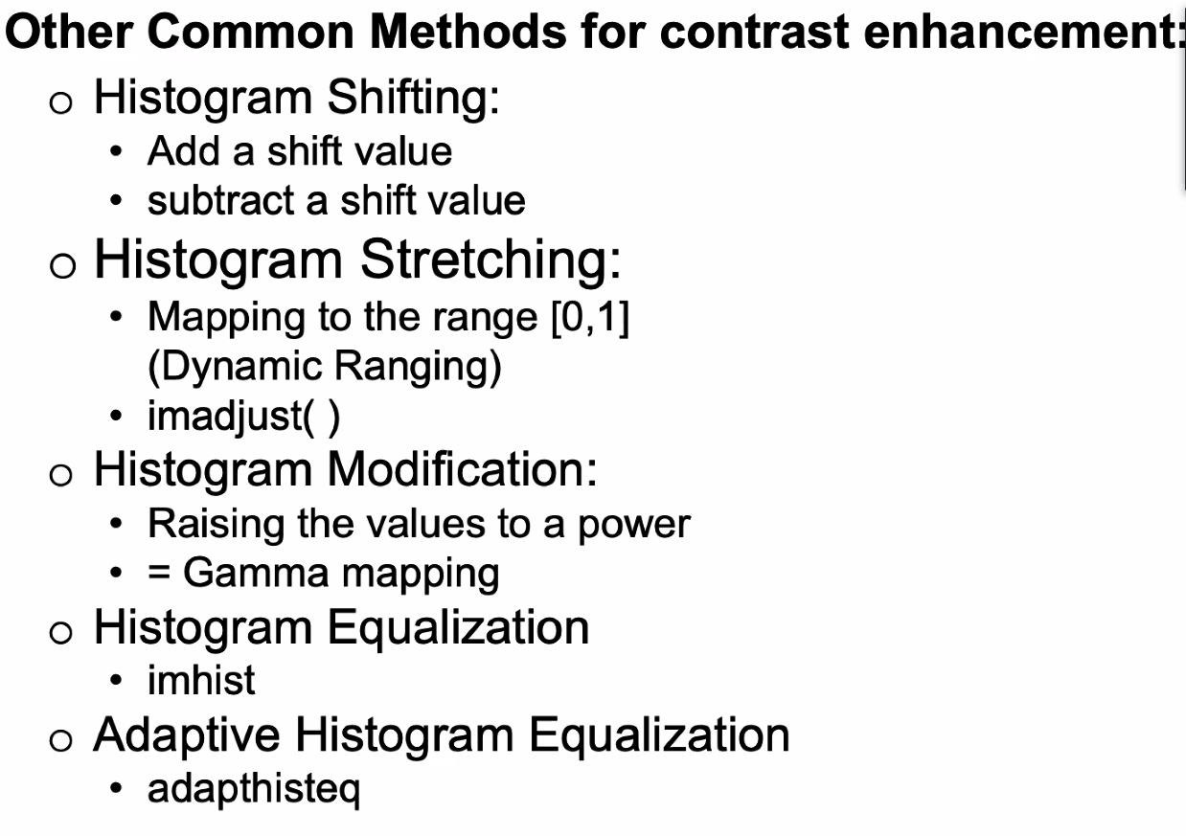

9/13/22

* linear filters - doing many things individually is the same as doing them all at the same time; like buying fruit per pound, 1 orange at a time 10 times vs buying 10 oranges once
* gaussian filters - more importance on the center
* averaging filters only have positive numbers
* differencing filters will have some sort of [-1, 0, 1] in the filter

# WEEK 5

9/20/22

* artificial neural networks do similar tasks but take longer to train
* using an imaging chain
  + only needs one exemplary image while NN require a lot
  + easier to debug
  + you can understand all of the steps along the way
  + usually when it fails, you know why it failed
  + you have a degree of confidence
* The human eye is a camera
  + lens - changes shape using ciliary muscles
  + pupil - the aperture whose size is controlled by the iris
  + iris - colored annulus with radial muscles
  + retina - photoreceptor cells (made up of rods and cones), used as the film
* Fovea has the least amount of rods, high cones
* Cones
  + used for color vision
  + less sensitive
  + operate in high light
* Rods
  + used for gray-scale vision
  + highly sensitive
  + operate in low light

9/22/22

* Noise is just anything we don’t want in the image
* trichromacy
* HSV - Hue Saturation and Value
* CIELAB
  + L - Luminance
  + a* = +a (red) vs -a (green)
  + b* = +b(yellow) vs -b(blue)
  + 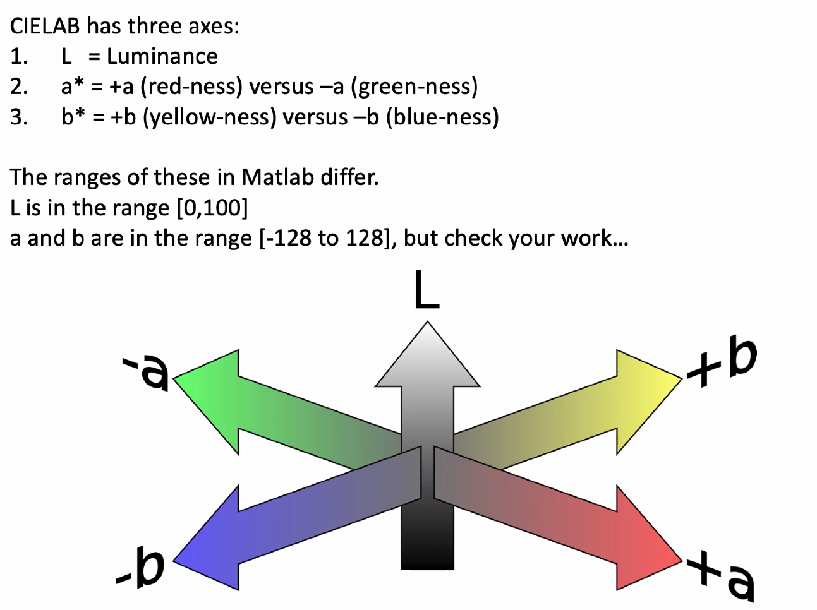

WEEK 6

* method for noise removal
  + median filtering - removes highs and lows by taking a group of pixels and replacing them with the median of that group
  + gaussian filtering - removes the highest and lowest pixels from and image
  + “binning the image in to bins” - divide every pixel into four